Research Proposal

Measuring the Robustness of Image Pattern Recognition Models Under Progressive Information Loss

1. Introduction
Image pattern recognition has become a core component of modern computer vision systems, with applications in object detection, medical imaging, astronomy, surveillance, and autonomous systems. Most image recognition models achieve high accuracy when trained and tested on clean, complete datasets. However, in real-world scenarios, image data often suffers from information loss due to noise, occlusion, low resolution, sensor limitations, or transmission errors.
For example, astronomical images of galaxies are frequently incomplete or distorted due to distance, atmospheric interference, and telescope limitations. Similarly, in handwritten digit recognition or object recognition tasks, humans can often recognize patterns even when large portions of the image are missing, while machines may fail.
This motivates the need to systematically study how image recognition models behave when image information is progressively degraded, and to identify the point at which recognition performance collapses. In this research, a controlled experimental framework is proposed where image data is gradually corrupted, and the recognition performance of machine learning models is evaluated. The goal is not to improve accuracy, but to measure the limits of pattern recognizability.

2. Problem Statement
Despite significant progress in image recognition, existing models are primarily evaluated under ideal or slightly noisy conditions. There is limited research on quantifying how much information loss an image can tolerate before recognition fails completely.
The exact problem addressed in this research is:
At what level of information loss does an image pattern become unrecognizable to a machine learning model?
This is a problem because:
Real-world image data is often incomplete or degraded.
Most existing solutions focus on improving robustness, not on identifying failure thresholds.
There is no standard metric to define a pattern recognition breakpoint.
Existing studies analyze accuracy degradation but do not explicitly define or measure the collapse point of recognition, which limits understanding of model reliability in critical applications.

3. Research Objectives

3.1 General Objective
To analyze and quantify the robustness of image pattern recognition models under progressive information loss.

3.2 Specific Objectives
To design an image pattern recognition model using machine learning techniques.
To collect and preprocess image datasets with controlled degradation.
To evaluate model performance under varying levels of information loss using standard metrics.
To identify the breakpoint where recognition accuracy significantly collapses.
To compare robustness behavior across different degradation methods.

4. Literature Review
Recent research has explored robustness of image recognition under noise, blur, and occlusion. DeepCorrect (2017) analyzed how image distortions affect CNN features and proposed correction mechanisms. Studies on compositional CNNs demonstrated improved robustness to partial occlusion but focused on architectural improvements rather than failure analysis. Other works examined recognition accuracy under noisy or degraded images, mainly aiming to improve performance through preprocessing or robust training.
Research on occlusion handling and noise immunity shows that recognition accuracy decreases gradually as distortion increases. However, most existing studies stop at performance improvement, not at defining the exact point where pattern recognition fails. Furthermore, limited work exists on systematically measuring progressive information loss and mapping it to recognition collapse.
The research gap lies in the lack of a quantitative framework to identify and analyze pattern collapse thresholds. This study differs by focusing on failure behavior, not optimization, and by introducing a breakpoint-based evaluation approach.

5. Methodology

5.1 Data Collection
Dataset Source:
MNIST handwritten digit dataset.
Simple object images (e.g., apple images) or synthetic shape datasets.

Number of Samples:
10,000–60,000 images (depending on dataset)
Features:
Pixel intensity values
Structural and spatial patterns

5.2 Data Preprocessing
- Image resizing and normalization.
- Conversion to grayscale (if required).
- Progressive data degradation techniques:
Random pixel removal
Structured masking (partial occlusion)
Gaussian noise and blurring

5.3 Proposed Model/System Design
Algorithm Used:
Convolutional Neural Network (CNN) as baseline.
Optional comparison with traditional classifiers (SVM/KNN).
System Architecture:
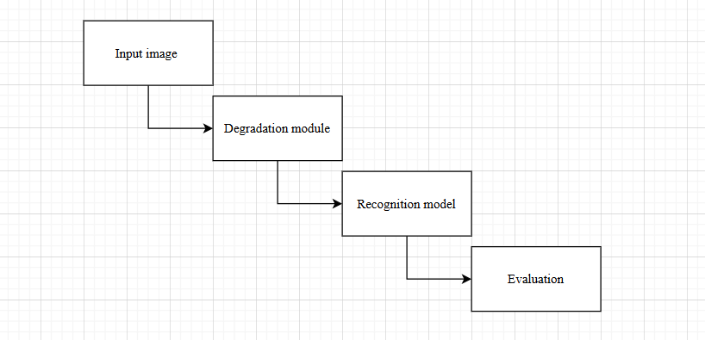
Tools/Software:
- Python
- TensorFlow / PyTorch
- OpenCV
- Matplotlib

5.4 Evaluation Metrics
- Accuracy
- Precision
- Recall
- F1-score
Additionally, a Breakpoint Metric will be defined as the level of information loss where accuracy falls below a predefined threshold (e.g., 60%).

6. Expected Outcomes
A clear relationship between information loss and recognition accuracy
Identification of pattern recognition breakpoints for different degradation methods
Graphical visualization of degradation curves
Insights into reliability of image recognition systems under incomplete data
A methodological foundation applicable to astronomy, medical imaging, and real-world sensing systems

7. Timeline
Month | Activities | Detailed Tasks | Expected Deliverables
Month 1 | Literature Review & Dataset Selection | Study recent research papers on image recognition robustness, occlusion, and noise. Identify research gaps related to pattern recognition failure  Select suitable datasets (MNIST, simple object images). Define evaluation strategy and degradation parameters | Literature review summary. Selected dataset(s). Finalized problem formulation
Month 2 | Data Preprocessing & Degradation Implementation0 | Image normalization and resizing. Dataset cleaning and formatting. Implementation of progressive degradation techniques (pixel removal, masking, noise, blur). Verification of degraded datasets | Preprocessed dataset. Degraded dataset versions. Data preparation scripts
Month 3 | Model Development & Training | Design and implementation of baseline CNN model. Training model on clean dataset. Training model on progressively degraded datasets. Hyperparameter tuning (learning rate, epochs) | Trained recognition models. Training logs and accuracy reports
Month 4 | Testing, Evaluation & Result Analysis | Model testing on unseen degraded data. Performance evaluation using accuracy, precision, recall, and F1-score. Generation of accuracy vs information loss graphs. Identification of recognition breakpoints | Evaluation results. Graphs and performance tables. Breakpoint analysis
Month 5 | Documentation & Final Report Preparation | Interpretation of experimental results. Discussion of limitations and future work. Writing final project report and proposal refinement. Preparation of presentation slides (if required) | Final project report.  Figures and tables.  Presentation materials.

8. Required Resources
Hardware: Laptop / Desktop (GPU optional)
Software: Python, TensorFlow/PyTorch, OpenCV
Dataset: MNIST, custom object image datasets
Lab Facilities: Computer lab with internet access

9. Conclusion
This research aims to systematically investigate the behavior of image pattern recognition models when subjected to progressive information loss in input data. Instead of focusing solely on improving classification accuracy, the study emphasizes understanding when and why recognition fails as image information is gradually degraded through noise, occlusion, or pixel removal. By analyzing the degradation patterns and identifying critical breakpoints where recognition performance collapses, this research provides deeper insight into the inherent limitations and reliability of existing image recognition models.
The proposed experimental framework is designed to be feasible at the undergraduate level while maintaining strong analytical depth. Furthermore, the methodology established in this study offers significant potential for future extension into advanced computer vision applications and physics-based imaging domains, such as astronomical image analysis and other real-world scenarios where data incompleteness is unavoidable.

10. References
- DeepCorrect: Correcting DNN Models against Image Distortions, 2017
- Robustness of CNNs to Noise and Blur, 2020
- Compositional CNNs for Partial Occlusion, 2020
- Noise Immunity Study of Image Recognition Systems, 2022
- Transfer Learning under Image Degradation, 2021
- Occlusion Robustness in Object Recognition, 2019
- Survey on Robust Visual Recognition, 2023
- Image Recognition with Incomplete Data, 2020
- Pattern Recognition under Uncertainty, 2018
- Evaluation Metrics for Image Classification, 2019

